Dynamics NAV Rapid Implementation Methodology

Users Guide

Microsoft Dynamics Nav®

Disclaimer:
This material is for informational purposes only. Microsoft Business Solutions ApS disclaims all warranties and conditions with regard to use of the material for other purposes. Microsoft Business Solutions ApS shall not, at any time, be liable for any special, direct, indirect or consequential damages, whether in an action of contract, negligence or other action arising out of or in connection with the use or performance of the material. Nothing herein should be construed as constituting any kind of warranty.

The example companies, organizations, products, domain names, email addresses, logos, people and events depicted herein are fictitious. No association with any real company, organization, product, domain name, e-mail address, logo, person, or event is intended or should be inferred. The names of actual companies and products mentioned herein may be the trademarks of their respective owners.

Copyright Notice:
Copyright © 2026 Microsoft Business Solutions ApS, Denmark. All rights reserved.

Trademark Notice:
Microsoft, Great Plains, Navision, Axapta, FRxare either registered trademarks or trademarks of Microsoft Corporation or Great Plains Software, Inc., FRx Software Corporation, or Microsoft Business Solutions ApS or their affiliates in the United States and/or other countries. Great Plains Software, Inc., FRx Software Corporation, and Microsoft Business Solutions ApS are subsidiaries of Microsoft Corporation.
Contents
Introduction 4
Project Schedule 4
Setup Questionnaire 4
Industry Specific Setup Data 4
Master Data Templates 4
Master Data Migration (Customer Legacy Data) 5
The Process 6
Step 1: Creating the new Company 7
Step 3: Applying the Setup Questionnaire 8
Step 3.1: Complete the Setup Questionnaire 8
Step 3.2: Validating the Setup Questionnaire 8
Step 3.3: Applying Answers from Setup Questionnaire 10
Step 4: Master Data Templates 10
Step 4.1 Choosing Master Data Templates 11
Step 4.2 Creating a Master Data Template 11
Step 4.3 Creating a record from a Master Data Template 12
Step 4.4 Using Master Data Template on a record 12
Step 5: Master Data Migration 13
Step 5.1 Choosing Master Data Migrations 13
Step 5.2 Creating Migration 13
Step 5.3 Exporting Migration Files 14
Step 5.4 Data entry 15
Step 5.5 Importing Data 15
Step 5.6 Validating Data 16
Step 5.7 Apply Data 17
Step 6: Implementation 17
Preparations 18
The Industry specific xml files 18
The Setup Questionnaire 18
How to create a questionnaire file 21
The Setup Data 21
Excel or XML file 22
The Partner Specific Data Set 22
Appendix 23
Setup Questionnaires 23
Master Data Templates 23
Migration Overview 24
Master Data Tables 25
Setup Data Tables 25
Master Data Templates Tables 26
Master Data Migration Tables 26
Questionnaire Tables 27

Introduction
The Dynamics NAV Rapid Implementation Methodology contains a toolkit developed to meet the needs of the Microsoft Business Solution Partners when they install and implement a new version of Dynamics NAV on the customer site.

The purpose of the tool is to reduce implementation time by:
- following the project schedule template
- importing Industry Specific Datasets
- defining System Setup in Excel and importing it into Dynamics NAV (Setup Questionnaire)
- importing customer data using XML (Master data Migration)
- simplifying the import and creation of data (Master Data Templates)
- reducing the need for Dynamics NAV trained users during the initial implementation phase.

The purpose of this Users Guide is to provide sufficient knowledge for a consultant to make use of the toolkit.

Project Schedule
In the Toolkit you will find a default Project Schedule for a Dynamics NAV Implementation, created in MS Project. Use this project schedule as your template for future Dynamics NAV implementation projects. Extend it to match the individual needs of each project.

Setup Questionnaire
The Setup Questionnaire guides the user through a set of questions. The questions and answers refer to the Setup Tables (79, 98, 311, 312, 313 etc.) in Dynamics NAV. When the user has finished answering the questions, the questionnaire XML file can be imported into Dynamics NAV. The consultant can then validate the questions and apply them to the Company Database. In this way, the database is basically set up without the user working the base and with only a minimum of consultancy assistance.

Industry Specific Setup Data
Every time a new Dynamics NAV solution is implemented, the company’s employees must learn and understand how to enter data. This requires both training of the end-users and the necessary time to enter new data.
Experience has shown that a number of tables contain data that are very similar for companies within the same specific industries. The Industry Specific Setup Data is a container of basic data, created by industry specialists. Importing this data will save implementation time and costs.

Example:
Tables 308 (No. Series) and 309 (No. Series Line) will be filled out with a set of number series and first numbers. In the Setup tables (98, 311, 312, 313 etc.), there are fields referring to number series. These fields will also be filled out. Therefore, the user does not need to spend time on inventing new number series. The Industry Specific Data is available as XML files. See Appendix 1 for a list of the tables covered.

Master Data Templates
When a new record is created in Dynamics NAV, there are some fields that are mandatory. Experience has shown that the mandatory fields, such as posting groups, payment terms etc. can be gathered in groups.

Example:
Mandatory fields for table 18 (Customer) can be grouped in; Domestic, Foreign and Export.

In Dynamics NAV Relationship Management, the Customer Template serves the purpose of filling out the mandatory fields when a customer is created from a contact.

The Master Data Templates is a tool similar to the Customer Template. But it is designed to apply to any table in the Dynamics NAV Database. With very little customization the template structure can be applied to any relevant area in the Dynamics NAV application. The tool is delivered with a set of industry-specific templates for the following tables: 15 G/L Account, 18 Customer, 23 Vendor, 27 Inventory, 5050 Contact.

Master Data Migration (Customer Legacy Data)
Any Dynamics NAV implementation faces the task of getting the customer legacy data moved from the old system to Dynamics NAV. This can either be done automatically via data ports or manually by entering data.

The Migration Interface where you decide tables and fields has a completely new look. In addition, ready to use Master Data Templates (see below) have now been introduced.

You can define tables and fields in Dynamics NAV and then create an XML file. The XML file can be opened by the user in Excel. The user can then enter or transfer his legacy data to the Excel worksheets. The Excel worksheets are saved as XML files. The tool can then import data from the XML files to the Dynamics NAV database.

The Data Migration tool provides an overview of all data imported into the Dynamics NAV base, with the possibility to validate data before applying it to the Dynamics NAV Tables.

When importing the Industry Specific Data Set, the Migration tool is filled out with a line for each table being imported. The Industry Specific Data Set also contains migrations for the following Master Data Tables: 15 G/L Account, 18 Customer, 23 Vendor, 27 Inventory, 5050 Contact.

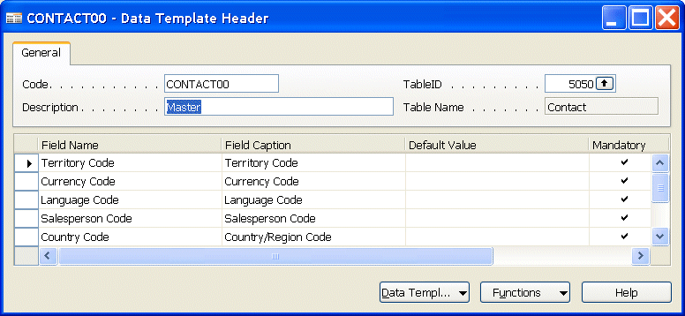

The Process
The following chapter will guide you through the use of RIM in the recommended sequence. It is highly recommended that you “try it out” a few times before using it for a live implementation.
Once you get to know the tool, spend some time investigating how you can simplify your implementations by building more templates and datasets.

Precondition
You are a Dynamics NAV super user/trained consultant. You have installed a standard Dynamics NAV 5.0 client and opened the standard demo database with the CRONUS Company.

All the industry-specific data files are stored in the Company Settings folder on the Application Client.

RIM is available from the Navigation Pane:

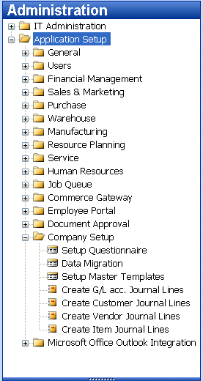

Step 1: Creating the new Company
- Open the Dynamics NAV Database and create a new company.
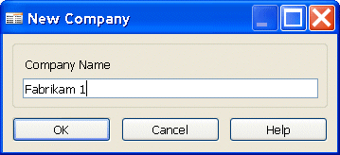
- After entering Company Name, the Company Setup window opens:
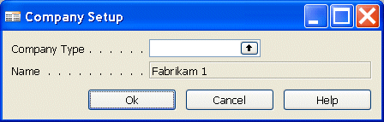
- Pres F6 in the Company Type field.
- Select Company Type and select the Industry Segment.
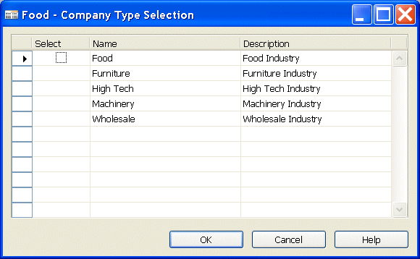
- Click OK in the Company Type Selection window.
The system will now import the industry-specific data for the selected company type.

Step 3: Applying the Setup Questionnaire
The following steps will take you through the procedure of exporting, completing, importing and applying data from the Setup Questionnaire.

Precondition:
The Setup Questionnaire is exported and must be completed and the Questionnaire Excel or XML files available.

Step 3.1: Complete the Setup Questionnaire
- In the Navigation Pane, click the Administration button, and then click Application Setup, Company Setup, Setup Questionnaire to open the Setup Questionnaire window:
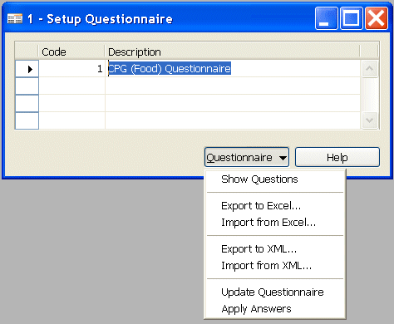
- Click the Questionnaire button, and then click Export to Excel or Export to XML.
- Save filename for the questionnaires you worked with in step 1.
Complete the Setup Questionnaire by enter the answers
- Click the Questionnaire button, and the click Import from Excel or Import from XML. Select the filename and path for the questionnaire you worked with in step 2. After you have imported the data, the form will be filled out with imported data (your data may be different from this example):

Step 3.2: Validating the Setup Questionnaire
The validation is the consultant’s assurance that the fields are filled out correctly. The validation is necessary because the system cannot validate a field in the questionnaire table with the data type of the corresponding Dynamics NAV field.

- Click the Questionnaire button and then click Show Questions.
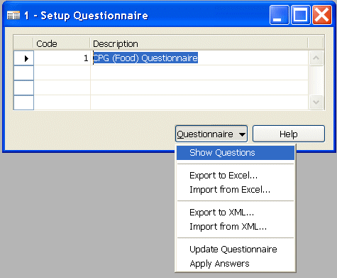
- The Question Area window opens:
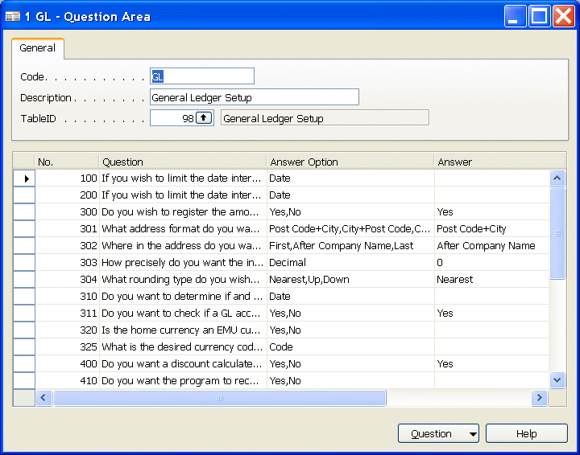
- For each question area, you must now validate the column Answer to the corresponding Dynamics NAV field. You can see the corresponding Dynamics NAV Field using the Ctrl+F8 combination.
Note:
Validation is a manual process. There is no automatic Dynamics NAV field validation.
- Click the Question button and then List (or press F5) to get a list of the different question areas:
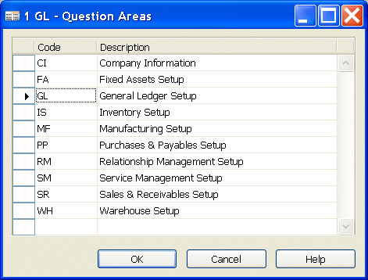
- You must validate all answers in all Question Areas.

Step 3.3: Applying Answers from Setup Questionnaire
You can transfer the answers to the Setup tables in 2 ways:

- For each question area click Apply Answers.
- For the entire questionnaire click Apply Answers in the Setup Questionnaire list.

Click the Questionnaire button and then click Show Questions.

Step 4: Master Data Templates
The following steps take you through the creation of Master Data Templates. The Master Data Templates are very helpful for the Master Data Migration, therefore it is recommended that you create these first. When choosing a company type in Step 1, a set of Master Data Templates are also imported. The set contains 5-8 templates for each of the following tables:
15 G/L Account, 18 Customer, 23 Vendor, 27 Inventory, 5050 Contact.

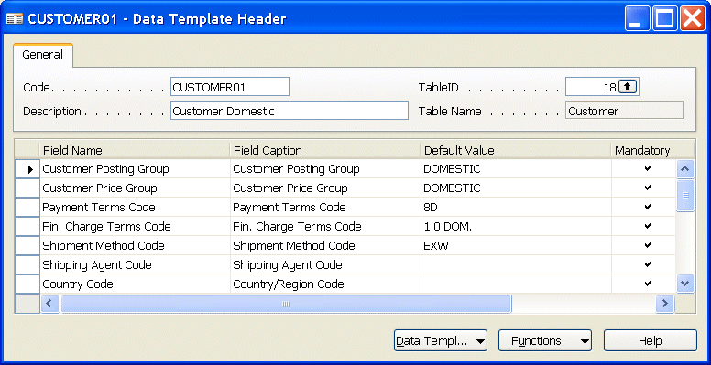

Step 4.1 Choosing Master Data Templates
The first step is to evaluate if the default Master Data Templates are sufficient for the Company. Go through the fields and values of each template and reach agreement with the company which templates can be used for what type of customer:

- If the default templates are not sufficient, Step 4.2 Creating a Master Data Template will guide you through the creation of new templates.
- If the default templates are sufficient, go to Step 4.3 Creating a record from a Master Data Template.

Tip:
Templates can be applied to any Dynamics NAV table – use them for faster and more accurate data creation.

Step 4.2 Creating a Master Data Template
In a Data Template Header, press F3 (New) and fill out the fields: Code, Table ID and Description.

Tip:
The Master Data Templates are all created in the same 2 tables (Header/Lines). The Code field is the unique ID for a template. Therefore, it is recommended that you follow specific rules for the customer when filling out the Code field.

Example:
- The simplest way is to create a non-logical sequential numbering (1, 2, 3, etc)
- It is often useful to apply some logic when specifying the IDs (CUS001, CUS002, ITEM001,ITEM002, etc)
- Place the cursor in the Field Name field and click the lookup button (or press F6) to select a field.
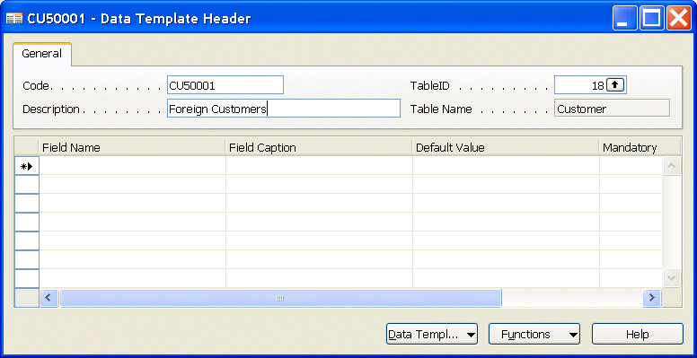
- In the Default Value field, enter the value.
- Place a checkmark in the Mandatory field if the field must be filled out for the Dynamics NAV application to work.
Example:
If Posting Groups are not filled out, an order cannot be invoiced. It is therefore mandatory to set up posting groups.
- In the Comment field, you can enter a comment about the field.

Tip:
Since the Default Value field does not have a lookup to the corresponding Dynamics NAV field options, you can open the standard form for the table and then Copy/Paste the value into the template.

Step 4.3 Creating a record from a Master Data Template
- To create a record from a template, select the template.
- Click the Functions button and then click Create Instance to create a record with the default values:
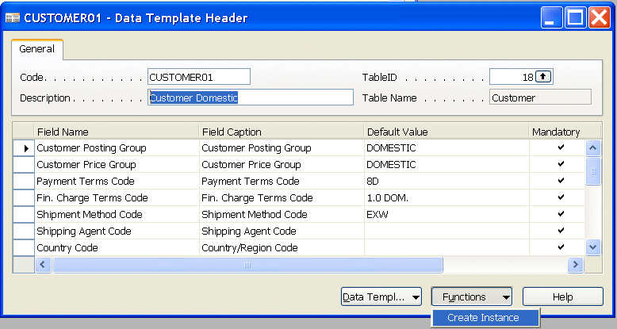

Step 4.4 Using Master Data Template on a record
- Create a new record (see the example below for a new customer):
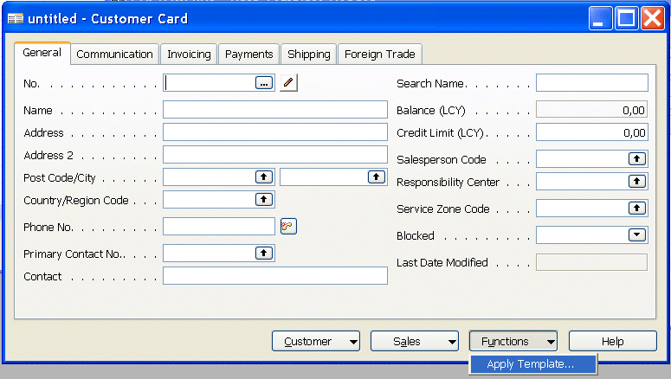
- After the record number has been defined, click on the Functions button and then on Apply Template….
The default values will now be copied from the template to the record.

Tip:
The Apply Template function can be used on any record. Consider this as a general feature to change records.

Warning:
The Apply Template function overwrites data in the record. If this function is used in the Master Data Migration (see next step), it will overwrite the imported data when creating records.

Step 5: Master Data Migration
Master Data Migration is a tool to transfer data from the company’s legacy system to Dynamics NAV using XML files as data carrier.

When choosing a company type in Step 1, a corresponding set of Master Data Migrations is imported. The Data set contains a Master Data Migration setup for the Master Data Tables and for the Setup Data Tables (sees Appendix 1 for a list of the tables).

The following steps walk you through the process of Master Data Migration using the default Migrations.

Step 5.1 Choosing Master Data Migrations
The first step is to evaluate if the default Master Data Migrations are sufficient for the company.

- Are the 5 tables sufficient?
- Are the field selections sufficient? (to check this, press F6 in the Fields Included field )

Notice that data will be imported in combination with Master Data Templates selected in field Data Template. Therefore, data covered by the Master Data Templates should not be imported.
- If the default Migrations are not sufficient, Step 5.2 Creating Migration will guide you through the creation of new migrations.
- If the defaults Master Data Migrations are sufficient, go to Step 5.3 Exporting Migration Files .

Tip:
Migrations can be applied to any Dynamics NAV table – use them for faster and more accurate data transfer.

Step 5.2 Creating Migration
- Open the Migration Overview window, and place the cursor in the lines area.
- Create a new line (F3).
- In the TableID field, enter a table number (or press F6 for lookup), for example TableID=90.
The Table Name field will be filled out automatically.
- Go to the Fields Included field and click F6 (or click the Data Migration button and then Migration Fields) to open the Migration Fields window:
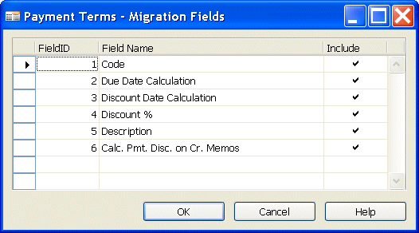
- Place a checkmark in the Include field to select the fields to be migrated and press Esc.
Notice that the value in the Fields Included field changes to “Yes”.

Step 5.3 Exporting Migration Files
- Open the Migration Overview window.
- Select the table you want to create a file from.
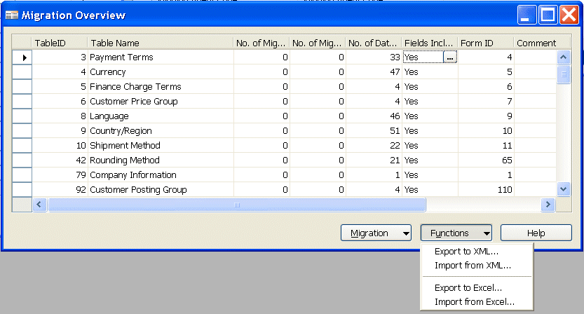
- Click the Functions button and then click Export to XML or Export to Excel.
- Save file name and click on the SAVE button.

An XML or Excel file containing only headlines will now be created at the specified position.
If you want to export only the migration, make sure the selected table does not contain any data as it will be exported with the migration. See chapter Preparations for more information on XML files.

Repeat this step for all relevant tables.

Tip: Consider how you name the files (examples: Table18.xml, Customers.xml)

Step 5.4 Data entry
- Open Excel.
- In Excel, click Open and browse to the relevant Migration Data file.
- Open the file.
- Show the customer how to fill out the worksheets. The following methods can be used.
Method 1:
- Open Sheet1 of the file in Excel.
- Enter all customers by filling out the fields line by line.
Method 2:
- Open Sheet2 of the file in Excel.
- Copy all customers to this sheet.
- Make an Excel formula (=Sheet2!A2’) between the fields in Sheet1 and fields in Sheet2.
Warning!
Do not change the columns in sheet1. If they are moved, deleted or changed, the sheet can not be imported.

Tip:
Since Customer legacy data is not organized as Dynamics NAV, it is recommended that you use method 2.
- Save the Excel worksheet and make sure you do not change the file type.

Step 5.5 Importing Data
- Open the Migration Overview window.
- Select the tables you want to import a data file from.
- Click the Functions button and then click Import Setup Data.
- Enter the path and file name and click OK.
Data from the file will now be imported into the migration tables.
In the Migration Overview window, the field No. of Migration Records shows the number of records imported.

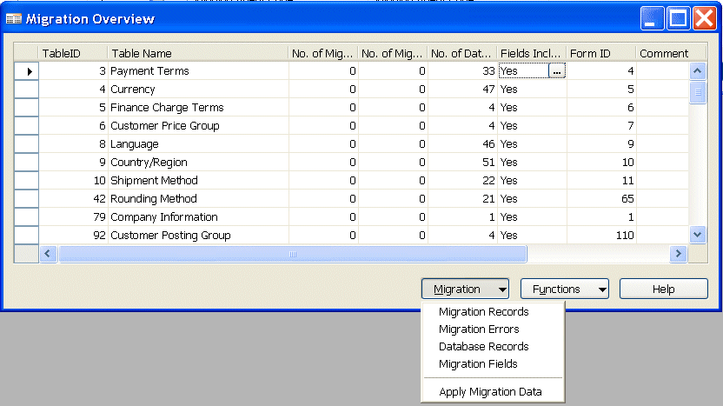

Tip: When applying the imported data (Step 5.7), the Master Data Templates will be used. It is recommended that you import and apply data in groups according to the Master Data Template.

Step 5.6 Validating Data
- Open the Migration Overview window by clicking the Migration button and then clicking Migration Records (or press F6 in the No. of Migration Records field:
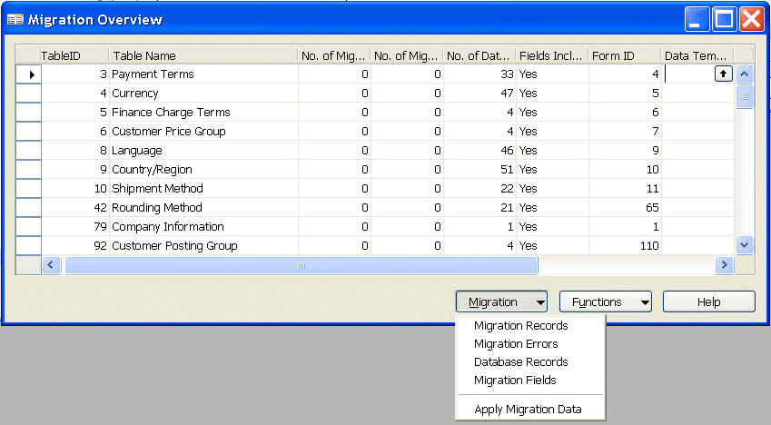
- Select the list Migration Records. You can edit all imported data.
If you change or enter data in a field, the Dynamics NAV field validation to the corresponding Dynamics NAV field will be executed.
A checkmark in the column Invalid indicates that the first line is invalid.
- Click the Migration button and select the list Migration Errors to see the errors:
- The error message explains the error type. Go through the list and change all invalid data.

Step 5.7 Apply Data
- If no records are invalid, click the Migration button.
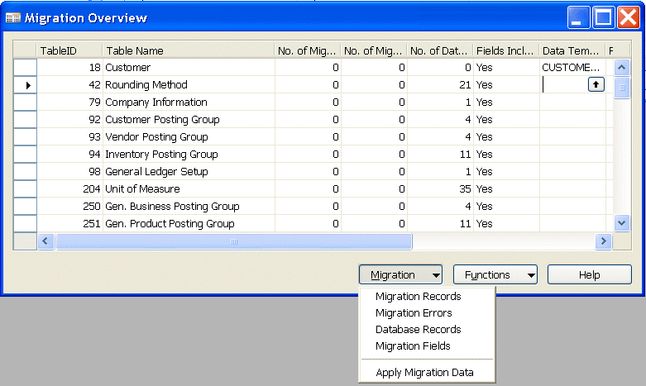

- Select the Master Data Template you want to apply to all data from the Migration Overview.
Note:
Master Data Template overwrites data in the record. If a field in the Master Data Migration is filled out and the same field has a value in the applied Master Data Template, the Master Data Template data will overwrite the Migration data. Benefit from this to reduce the number of fields that need to be imported.

Tip:
It is recommended that you import and apply data in groups according to the Master Data Template.

- Click Apply Migration Data

Step 6: Implementation
If you have followed the steps above, the company database is now set up and basic data is imported. Your next steps in the implementation process are training of the users, definition of processes, further data creation, customization of reports etc.

A part of this tool is a default Project Schedule. You can use this Project Schedule as your guide through the implementation. But remember that it is a default Project Schedule, and no projects run by default. So use the Project Schedule as your template. Change it depending on the specific project at hand. Extend it to larger projects. Use it the best way you can to make each of your Dynamics NAV Projects a success.

Preparations
The following chapter will guide you through the extended use of the Implementation Toolkit.
Including the necessary preparation for the process described above.

Precondition
You are a Dynamics NAV super user/trained consultant. You have installed a standard Dynamics NAV 5.0 client including the toolkit and opened the standard demo database with the CRONUS Company.
All the industry-specific data files are stored in the Company Settings folder on the Application Client.

The Industry specific xml files
The toolkit contains the Industry Specific xml files. The filenames are:
- Food.xml
- Furniture.xml
- HighTech.xml
- Machinery.xml
- WholeSale.xml

Each file contains data that can be imported to the Dynamics NAV company during the creation of a new company (see step 2 in previous chapter).
The data in each file are:
- A set of Questionnaires for the setup tables (see appendix)
- A set of Master Data Templates (see appendix)
- A set of Data. (see appendix)

The Setup Questionnaire
The Setup Questionnaire is available from the Navigation Pane:

The Setup Questionnaire window shows the different questionnaires.

Each line contains one or more question areas
To see the question areas click on the Questionnaire button and select Show Questions:

This is the Question Area window for questions to table 98 General Ledger:

Each line refers to a specific field in the related table. The column Answer is contains the value that can be imported to the related table.

If you click on the Question button and select List…

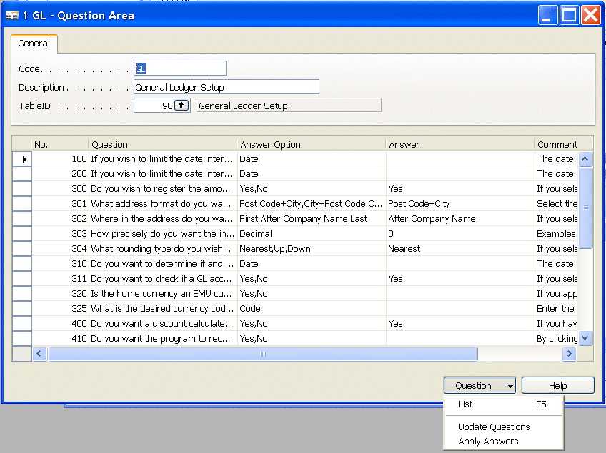

… you will get this list of the different question areas:

How to create a questionnaire file
In the Setup Questionnaire window you can choose how to export the questionnaire.

You can export either to Excel or XML. Below the consequence of each selection will be shown. Either way the data can be shown and edited in Excel and imported to Dynamics NAV.

Tip:
Work with both methods and find the most suitable for you.
Your preparation before seeing the customer is to create the questionnaire file.

The Setup Data
When you import (step 2 in the process above) 67 tables will be filled out with Industry Specific data. The data are created from knowledge of the Industries. Many of the data are similar from industry to industry. Use these data to jump start your implementations.

Excel or XML file
Questionnaires and Migration Data both have import and export functionality that can use Excel and XML file formats. The following will show you how to handle the different file formats.

Excel:
If you export to Excel and data can be filled in and the workbook can be saved as Excel and imported to Dynamics NAV.

XML:
If you export to XML, XML can be used in many other applications, which opens possibilities for automated data Migration.

Options:
If you select As an XML list you will get an XML List created in a new Excel workbook.
The contents of the file are imported into an XML list. IF the XML data file does not refer to a schema then Excel will infer the schema of the XML data file.

If you select as a read-only Workbook, the XML data file is opened as a read-only Excel workbook. The structure of the file is flattened.

If you select Use the XML task Pane, you will get an Excel workbook that looks like this:
The schema of the XML data file is displayed in the XML Source task pane. You can then drag elements of the schema to the worksheet to map those elements to the worksheet.
If you are opening an XML data file that does not refer to a schema, then Excel will infer the schema of the XML data file.

Tip:
When working with data that you move between companies or between Dynamics NAV Databases, the XML file format is highly recommendable.
When you are working with data that has to be edited manually before importation, the Excel file format is highly recommendable. If you master the Excel/XML mappings, the XML file format is also recommended.

The Partner Specific Data Set
With this toolkit you have the opportunity to create data sets that match your customer’s needs. When your implementations require specific setup, you can build setup questionnaires that will apply to exactly your customers. When your implementations require specific data, you can build datasets that will apply to exactly your customers.

Here is the recommended way to do it:
- Use a blank Dynamics NAV database.
- Import the 5 vertical data sets.
- Edit/Change/Add to the Setup Questionnaires
- Edit/Change/Add data (Post codes, more master data templates and other tables are obvious candidates)
- Adjust the Migration overview to the new tables.
- Create your partner specific dataset as xml files.

Building your own sets of questionnaires will enhance your implementations.
This will make every Dynamics NAV implementation a success.

Appendix
This appendix shows the content of the company settings xml files.

Setup Questionnaires

Master Data Templates
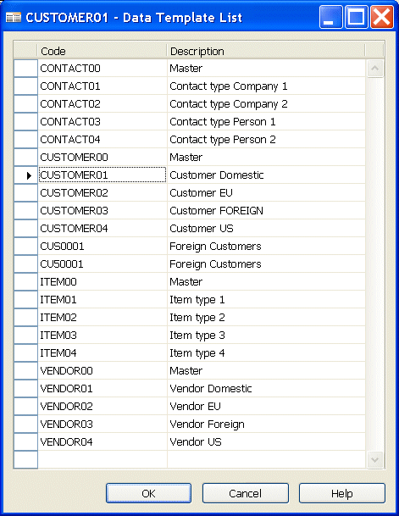

Migration Overview
The Migration Overview contains the following information:

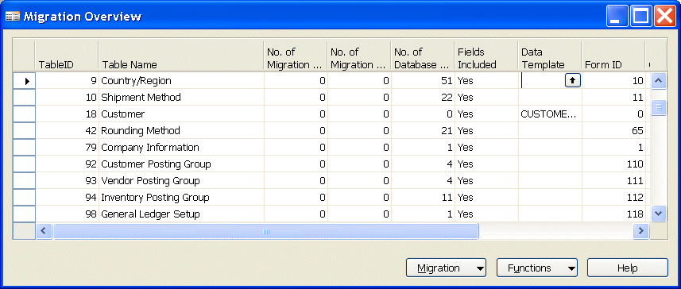

TableID: Enter a table number (or press F6 for lookup), the Table Name will be filled out automatically.

No of Migration records: Number of records imported from Excel or XML files

No of Migration Errors: Number of errors, must be corrected before Apply Migration Data

No of Data Base Records: Number of data updated in the database after using Apply Migration Data

To see the individual records use lookup (or press F6), please note if you want to look up data in the database a Form ID must be added in the field Form ID e.g. Form 1 Company information and data will be shown in Card form or Form 112 Inventory Posting Groups and the information will be shown in list form)

Status: The status field can be used to give information about the status of task, e.g. migration of customer.
Options:
- Not Started
- In Progress
- Completed

Fields Included: Selection of fields to be included in files to be imported from or exported to Excel or XML.

Data Template: Select what master data template linked to migration records before using the Apply Migration Data function

Master Data Tables
Table no. | Table name | Data from
15 | G/L Account | Company Settings XML files / Company Specific XML file
18 | Currency | Company Settings XML files / Company Specific XML file
23 | Customer | Company Settings XML files / Company Specific XML file
27 | Vendor | Company Settings XML files / Company Specific XML file
5050 | Contact | Company Settings XML files / Company Specific XML file

Setup Data Tables
Table no. | Table name | Data from
3 | Payment Terms | Company Settings XML files
4 | Currency | Company Settings XML files
5 | Finance Charge Terms | Company Settings XML files
6 | Customer Price Groups | Company Settings XML files
8 | Language | Company Settings XML files
9 | Country | Company Settings XML files
10 | Shipment Method | Company Settings XML files
42 | Rounding Method | Company Settings XML files
50 | Accounting Period | Company Settings XML files
79 | Company Information | Company Settings XML files/Questionnaire
80 | Gen. Journal Template | Company Settings XML files
82 | Item Journal Template | Company Settings XML files
92 | Customer Posting Group | Company Settings XML files
93 | Vendor Posting Group | Company Settings XML files
94 | Inventory Posting Group | Company Settings XML files
98 | General Ledger Setup | Company Settings XML files/Questionnaire
204 | Unit of Measure | Company Settings XML files
232 | Gen. Journal Batch | Company Settings XML files
250 | Gen. Business Posting Group | Company Settings XML files
251 | Gen. Product Posting Group | Company Settings XML files
252 | General Posting Setup | Company Settings XML files
289 | Payment Method | Company Settings XML files
291 | Shipping Agent | Company Settings XML files
308 | No. Series | Company Settings XML files
309 | No. Series Line | Company Settings XML files
311 | Sales & Receivables Setup | Company Settings XML files/Questionnaire
312 | Purchases & Payables Setup | Company Settings XML files/Questionnaire
313 | Inventory Setup | Company Settings XML files/Questionnaire
314 | Resources Setup | Company Settings XML files
315 | Jobs Setup | Company Settings XML files
323 | VAT Business Posting Group | Company Settings XML files
324 | VAT Product Posting Group | Company Settings XML files
325 | VAT Posting Setup | Company Settings XML files
340 | Customer Discount Group | Company Settings XML files
5053 | Business Relation | Company Settings XML files
5055 | Mailing Group | Company Settings XML files
5070 | Organization Level | Company Settings XML files
5079 | Relationship Management Setup | Company Settings XML files
5087 | Profile Questionnaire Header | Company Settings XML files
5088 | Profile Questionnaire Line | Company Settings XML files
5218 | Human Resources Setup | Company Settings XML files
5500 | Production Schedule Setup | Company Settings XML files
5603 | FA Setup | Company Settings XML files
5604 | FA Posting Type Setup | Company Settings XML files
5611 | Depreciation Book | Company Settings XML files
5619 | FA Journal Template | Company Settings XML files
5620 | FA Journal Batch | Company Settings XML files
5700 | Stockkeeping Unit | Company Settings XML files
5714 | Responsibility Center | Company Settings XML files
5769 | Warehouse Setup | Company Settings XML files
5790 | Shipping Agent Services | Company Settings XML files
5911 | Service Mgt. Setup | Company Settings XML files/Questionnaire
6081 | Serv. Price Group Setup | Company Settings XML files
6502 | Item Tracking Code | Company Settings XML files
7303 | Bin Type | Company Settings XML files
7304 | Warehouse Class | Company Settings XML files
7335 | Bin Template | Company Settings XML files
7336 | Bin Creation WKSH template | Company Settings XML files
7337 | Bin Creation WKSH Name | Company Settings XML files
7600 | Base Calendar | Company Settings XML files
99000750 | Work Shift | Company Settings XML files
99000751 | Shop Calendar | Company Settings XML files
99000752 | Shop Calendar Working days | Company Settings XML files
99000756 | Work Center Group | Company Settings XML files
99000765 | Manufacturing Setup | Company Settings XML files
99000778 | Standard task | Company Settings XML files
99000780 | Capacity Unit of Measure | Company Settings XML files

Master Data Templates Tables
Table No. | Table Name | Data from
8618 | Data Template Header | Company Settings XML files
8619 | Data Template Line | Company Settings XML files

Master Data Migration Tables
Table No. | Table Name | Data from
8613 | Migration Table | Company Settings XML files
8614 | Migration Record | Company Settings XML files
8615 | Migration Data | Company Settings XML files
8616 | Migration Table Field | Company Settings XML files
8617 | Migration Data Error | Company Settings XML files
8620 | Company Type | Company Settings XML files

Questionnaire Tables
Table No. | Table Name | Data from
8610 | Setup Questionnaire | Company Settings XML files
8611 | Question Area | Company Settings XML files
8612 | Question | Company Settings XML files

