Business Notification
Installation Guide

Microsoft Business Solutions–Navision® Business Notification 4.00

Disclaimer:
This material is for informational purposes only. Microsoft Business Solutions ApS disclaims all warranties and conditions with regard to use of the material for other purposes. Microsoft Business Solutions ApS shall not, at any time, be liable for any special, direct, indirect or consequential damages, whether in an action of contract, negligence or other action arising out of or in connection with the use or performance of the material. Nothing herein should be construed as constituting any kind of warranty.

The example companies, organizations, products, domain names, email addresses, logos, people and events depicted herein are fictitious. No association with any real company, organization, product, domain name, e-mail address, logo, person, or event is intended or should be inferred. The names of actual companies and products mentioned herein may be the trademarks of their respective owners.

Copyright Notice:
Copyright © 20266 Microsoft Business Solutions ApS, Denmark. All rights reserved.

Trademark Notice:
Microsoft, Great Plains, Navision, Axapta, FRxare either registered trademarks or trademarks of Microsoft Corporation or Great Plains Software, Inc., FRx Software Corporation, or Microsoft Business Solutions ApS or their affiliates in the United States and/or other countries. Great Plains Software, Inc., FRx Software Corporation, and Microsoft Business Solutions ApS are subsidiaries of Microsoft Corporation.
Contents
This installation guide describes how to install both the Business Notification Client, and the Business Notification Server.
Business Notification Server 3
Installing the prerequisites on one computer 3
Installing the prerequisites on two computers 4
Installing the Business Notification Server 4
Business Notification Client 14
Client Prerequisites 14
Installing Business Notification Client 14
Post-installation Notes 15
Concerning the SMTP server 15

Business Notification Server
The Business Notification Server is installed with its own installation program. There are a number of different ways to set this up, depending on your infrastructure. Some of these choices will impact how you install.

You can install everything on one physical computer, or you can install on two computers. These two scenarios are described below.

In either case, the Navision Database Server is supposed to be installed already, either on a separate computer, or on one of the computers used for the Business Notification Server. Likewise, it is supposed that you have access to either an external SMTP server (for example, at your ISP), or that you are already running an SMTP server yourself.

The procedure for installing the Business Notification Server itself is the same in either case. This procedure is described after the descriptions of installation of the prerequisites.

Installing the prerequisites on one computer
Before you start, the following prerequisites must be installed:

- Operating System: Microsoft Windows 2000 Server SP4, or higher, or Microsoft Windows Server 2003 SP1, or higher.
- Microsoft .NET Framework 2.0. If you do not already have it, it can be installed using Windows Update (http://windowsupdate.microsoft.com). Do not uninstall the Microsoft .NET Framework 1.1 (if it is already installed) because other parts of Navision needs it.
- Microsoft SQL Server 2005, Standard or Enterprise Edition, SP1, or later.
- Microsoft Internet Information Services. On Windows Server 2003, you must make sure that ASP.NET is active (click Control Panel, Add or Remove Programs, Add/Remove Windows Components, Application Server->Details).
- Only on Windows 2000: MDAC 2.8 (available in the folder “Client\Microsoft Components\MDAC” on the Navision product CD.
- SQLXML 3.0 SP3. It can be downloaded here:
http://www.microsoft.com/downloads/details.aspx?FamilyID=51d4a154-8e23-47d2-a033-764259cfb53b&DisplayLang=en
Beware that there is a line break in the URL here: this is due to the formatting of the document.
- If you get an error dialog about “SOAP Toolkit missing”, you can safely ignore it.
- If you are using the Navision Database Server, version 4.0, as your main database it must already be installed. This guide only covers installation of the Business Notification Server. It is not a requirement that you use Microsoft SQL Server as your regular Navision database in order to run Business Notification – but Business Notification uses Microsoft SQL Server.
If you anticipate to use Business Notification extensively (have many schemes and send many e-mail notifications), you should be aware that this will require quite a few resources on the computer, and that you therefore should not install the Business Notification Server on the same computer as a Navision Database Server – this could impact the Navision performance negatively. Also, you should not run a Navision Application Server on the same machine as the one that is running the Business Notification server.

- The client should be kept running with the chosen database while you install the Business Notification Server.

- The domain user that you choose for the Business Notification user during setup should be given the “SUPER” role in Navision before the Business Notification server is installed.

- A Navision license file with Business Notification permissions should be in place before installation. Failing this, installation will appear to succeed, but Business Notification will not work as expected.

- You must have access to an SMTP server. See note at the end of this guide for more information.

When you have installed the prerequisites, proceed to install the Business Notification Server on this computer.

Installing the prerequisites on two computers
In this scenario, you will install the SQL Server on one computer, and the Business Notification Server on another.

Computer One: The SQL Server
On this computer you must install the following prerequisites:

- Operating System: Microsoft Windows 2000 Server SP4, or higher, or Microsoft Windows Server 2003 SP1, or higher.
- Microsoft SQL Server 2005, Standard or Enterprise Edition, SP1, or later.

Computer Two: The Business Notification Server
On this computer you must install the following prerequisites:

- Operating System: Microsoft Windows 2000 Server SP4, or higher, or Microsoft Windows Server 2003 SP1, or higher.
- Microsoft .NET Framework 1.
- Microsoft .NET Framework 2.0. If you do not already have it, it can be installed using Windows Update (http://windowsupdate.microsoft.com).
- Microsoft Internet Information Services. On Windows Server 2003, you must make sure that ASP.NET is active (click Control Panel, Add or Remove Programs, Add/Remove Windows Components, Application Server->Details).
- Only on Windows 2000: MDAC 2.8 (available in the folder “Client\Microsoft Components\MDAC” on the Navision product CD.
- SQLXML 3.0 SP3. It can be downloaded here:
http://www.microsoft.com/downloads/details.aspx?FamilyID=51d4a154-8e23-47d2-a033-764259cfb53b&DisplayLang=en
Beware that there is a line break in the URL here: this is due to the formatting of the document.
- If you get an error dialog about “SOAP Toolkit missing”, you can safely ignore it.
- The Microsoft SQL Server Notification Services from Microsoft SQL Server 2005. Install this by doing a Custom install of the Microsoft SQL Server 2005.
When you have installed the prerequisites, proceed to install the Business Notification Server on this computer, provided you also have these prerequisites ready:

- You must have a Navision Database Server, version 4.0, installed already. If you anticipate to use Business Notification extensively (have many schemes and send many e-mail notifications), you should be aware that this will require quite a few resources on the computer, and that you therefore should not install the Business Notification Server on the same computer as the Navision Database Server – this could impact the Navision performance negatively.
- You must have access to an SMTP server. See note at the end of this guide for more information.

Installing the Business Notification Server

The user performing the installation must be a member of the SQL Server sysadmin server role, and be a local administrator on the SQL Server computer as well.

During the installation, follow these steps and supply the following information:
- Run setup.exe, located in the folder “Additional Interfaces\Business Notification\BusinessNotificationServer”. The following dialog opens:
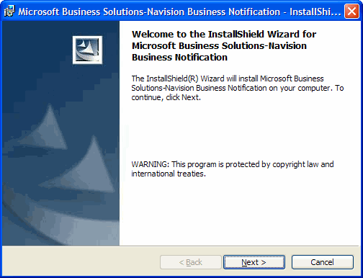
- Click Next. The User Information dialog opens:
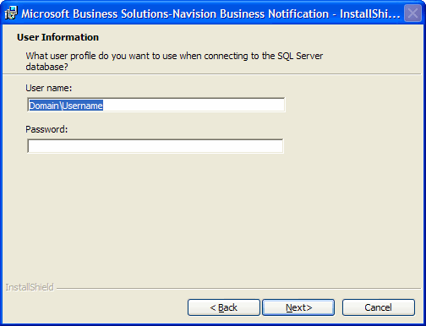
- Enter a user name (in the format "DOMAIN\username"). The user must be a valid Windows domain user but does not have to be the user who does the installation. The password for this user cannot be blank.
As mentioned earlier, this user must already be a member of a SUPER role in Navision. The important permissions are read and write permissions to table “2000000040 License Information” and table “9801 Property Store”.
It is, however, possible to install using a local user. This can be useful for demos and/or development. In order to do this, you must install the Business Notification Server and the SQL Server on the same machine. Enter the name of a local user on that machine when asked for a user profile. You cannot give permissions to groups in this case, as the information about groups is stored in the Windows domain.
- Click Next. The SQL server database selection dialog opens:
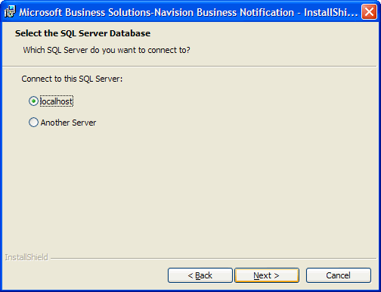
- Select the SQL Server database. If you are installing Business Notification on the same physical computer as the SQL Server, select localhost. If not, select Remote Server.
- Click next. If you select Remote Server, this dialog will open:
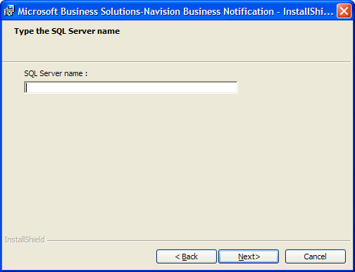
Enter the name of SQL server. If you want to use a specific instance, enter the name of this instance (the name of an instance is entered as SERVER\INSTANCE, for example: NAVISION\BN.). In some rare situations, you may not get a connection when using the SQL Server name. If so, using the IP address of the SQL Server machine may help.
Note: If you are using localhost because you are installing on the SQL Server computer, but you also want to use a specific instance, you will need to use a workaround, namely you must select Remote Server as though you are installing to a remote server, then enter the name of the local computer and then enter the specific instance when you get the opportunity.
- Click next (if you chose “localhost” in step 5, it will be in that dialog; else in the dialog shown in step 6.) The SMTP Server Information dialog opens:
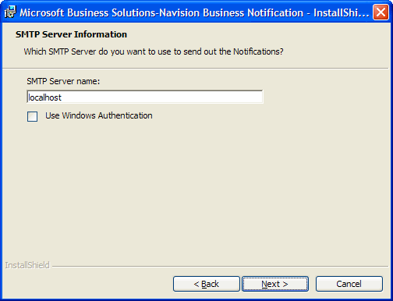
- Enter the name of your SMTP server either as an IP address or a server name. Check “Use Windows Authentication” if you are running an SMTP yourself, and it requires authentication.
- Click Next. The Navision Database Information dialog opens:
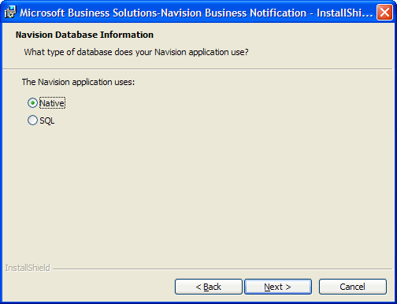
- Select Native or SQL, depending on what your Navision Database Server is using.
- If you select the Native database, this dialog will open:
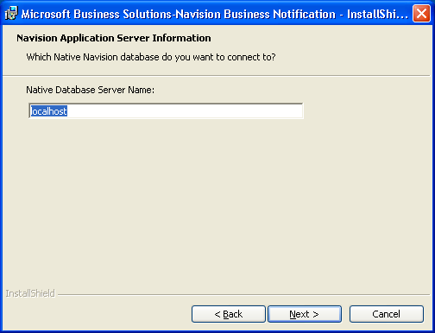
- Enter the name or IP address of the Navision database server. The default is 127.0.0.1 (localhost), which you can leave if your Navision server is running on the same physical computer as Business Notification.
- If you select the SQL server option, this dialog opens:
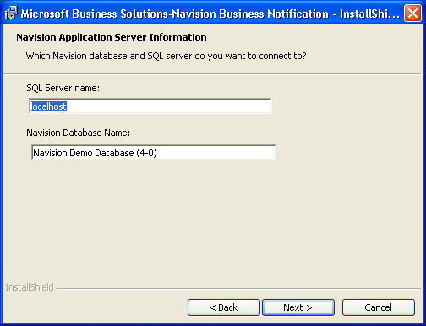
- Enter the name or IP address of the Navision database server. The default is 127.0.0.1 (localhost), which you can leave if your Navision server is running on the same physical computer as Business Notification. Enter the name of the Navision database
- Click Next in either the dialog shown in step 11 (Navision native database), or in the dialog shown in step 13 (SQL database). The following dialog opens:
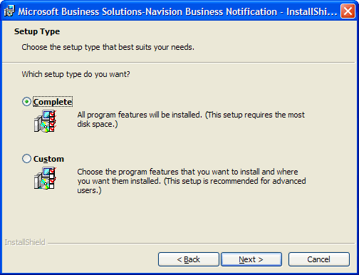
- Select Complete to install all program features, or Custom if you want to install in another folder than the default.
- Click Next. The following dialog opens:
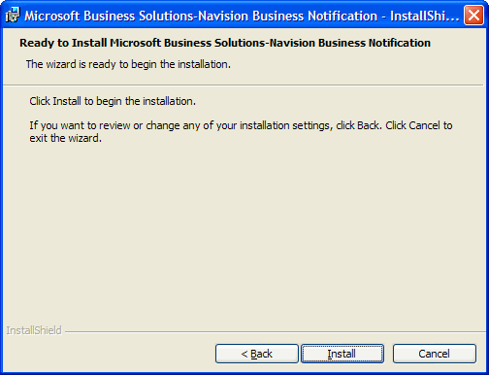
Note the following:
If the account you entered in step 2 above has not been used for running a service before, the following error message will occur:
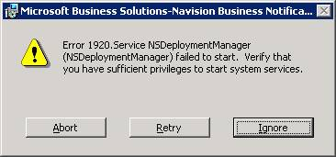
If, or when, you get this error, you must do the following without clicking anything in the dialog shown above:
Open the Services Management Console snap-in (for example: Control Panel, Administrative Tools, Services).
Find the service called “Notification Service Deployment Manager”.
Right-click the service, and click Properties in the context menu.
Click the “Log On” tab.
Enter the account details in “This account:”
Click OK.
Close Services.
Once you have done this, you can click Retry in the dialog shown above, and the installation will continue.

After installation, you should check the following:

It is important that the correct version of the Microsoft .NET Framework is used. In order to check this, open the Internet Information Services management console (Control Panel, Administrative Tools, Internet Information Services):

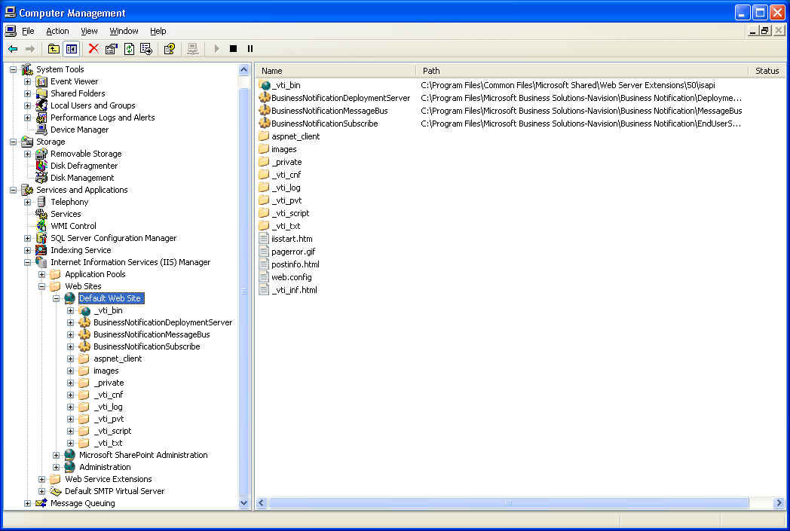

Right-click each of the three virtual directories used by Business Notification, and check that they use version 2.0 of the .NET Framework:

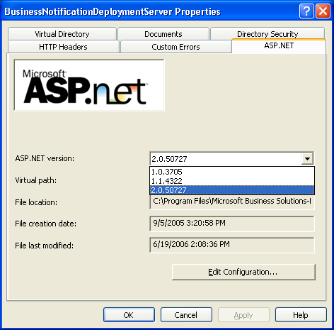

If they do not, change the setting to the correct one.

After changing it, restart the Internet Information Services

Business Notification Client
The Business Notification Client is installed as part of the Navision 4.0 Client installation. If you install Navision without installing Business Notification, you can add Business Notification later by running the Navision installation program again and choosing to change the installation.

IMPORTANT: The Business Notification Client must be installed on all computers running Navision in the company, even if you are not planning to use the client from all computers. Some components are installed with the client that are necessary for sending events from Navision to Business Notification. If you do not install the Business Notification Client on all computers running Navision, events “raised” by the Navision business logic on a computer without the client will be missed.

Client Prerequisites
- Operating System: Windows XP Professional SP1 or later, or Windows 2000 Professional SP4 or later.
- Microsoft .NET Framework 2.0. Do not uninstall version 1.1, if it is installed – other parts of Navision will need it.
- The user who does the installation must be a Windows domain user.

Installing Business Notification Client
- Run the Navision client setup program from the Navision installation CD.

To install Business Notification Client select either Complete to install all program features or select Custom to install Business Notification during a customized installation.

After installation, the Business Notification Client can be started from Start, Program Files, Microsoft Business Solutions-Navision.

Post-installation Notes and Troubleshooting
You must be (at least) a local system administrator on the computer where the Business Notification Server is installed when you use the Business Notification Client to add the first user to Business Notification. (After this, you can use this first user to add additional users without being an administrator.)

The Business Notification Server is started automatically when the operating system starts. The Business Notification Client can be started from Start, Program Files, Microsoft Business Solutions-Navision.

Troubleshooting
When you are using a Navision Database Server, the Business Notification Server may enter errors in the event log (as can be viewed in the Event Viewer.) It is easy to overlook these errors, as other entries are also made that do not signify actual errors. However, the following things are some to look out for when troubleshooting:

- The Navision Application Server that is used internally by Business Notification does not get fully started.
- The Property Store table is not populated with the necessary values.
- The NS$BusinessNotificationInstance is not started.

The solution is to go to the Business Notification Setup in Navision (Administration, IT Administration, General setup, Business Notification setup) and then change the Connection Type setup from TCPS to TCP, if you are using TCP. If you are using TCPS, change it back once again. The reason that this value is sometimes not written correctly to the registry. This will force the value you want to be written to the registry.

Concerning the SMTP server
As mentioned in the list of prerequisites, you will need to have access to an SMTP server in order to send out e-mail notifications.

If you are already running an SMTP server yourself, you will probably want to use this server. In this case, you probably (depending on how your setup is) want to check “Use Windows Authentication” during installation of the Business Notification Server (in step 8).

If you are using the SMTP that your ISP provides, you will not have any problems in most cases. If, however, this SMTP server requires authentication or TLS encryption, you cannot set the required parameters up, and you cannot send the mail, directly from Business Notification.

You can then use the SMTP server that comes with the Internet Information Services (which is a prerequisite anyway) as a relay, and set the required authentication or encryption up on this server.

The configuration for this SMTP server is accessed through Control Panel, Administrative Tools, Internet Information Services. You should consult the documentation for this product in order to find out how you can configure it to fulfill your specific requirements.

In this case, the SMTP server you tell Business Notification to use will be this one (the relay server.)

